Top down and Bottom up Design Methodologies
LAB # 02



Spring 2024
CSE-308L Digital System Design Lab

Submitted by: Ali Asghar
Registration No.: 21PWCSE2059
Class Section: C

“On my honor, as student of University of Engineering and Technology, I have neither given nor received unauthorized assistance on this academic work.”

Submitted to:
Dr. Asif Ali Khan

Date:
24th February 2024

Department of Computer Systems Engineering
University of Engineering and Technology, Peshawar
Objectives:
This lab will enable students to:
  - Learn top down and bottom up design methodologies
  - Data flow level modeling

Task 1:
4-bit Ripple Carry Adder

Block Diagram:
Following is the block diagram of a 4 bit Ripple Carry Adder.

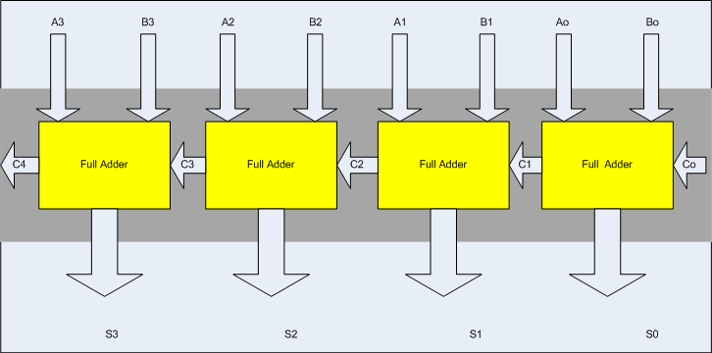

Steps for task 1a:
The following steps should be performed while designing a 4 bit RCA adder

ModelSim:
- First implement a Full adder using data gate level modeling.
- Simulate the Full adder with a test bench.
- Instantiate the Full adder four times and connect the circuit as shown.
- Now again write a test bench and simulate the 4 bit RCA

Code:
DUT:
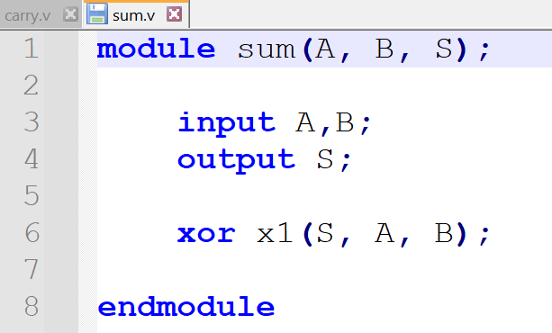
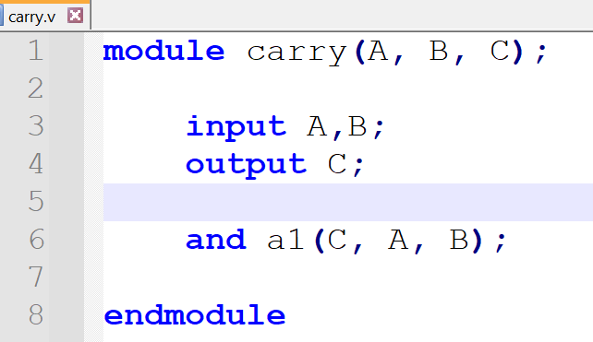
Figure 1.1: Carry Module
F
Figure 1.2: Sum Module

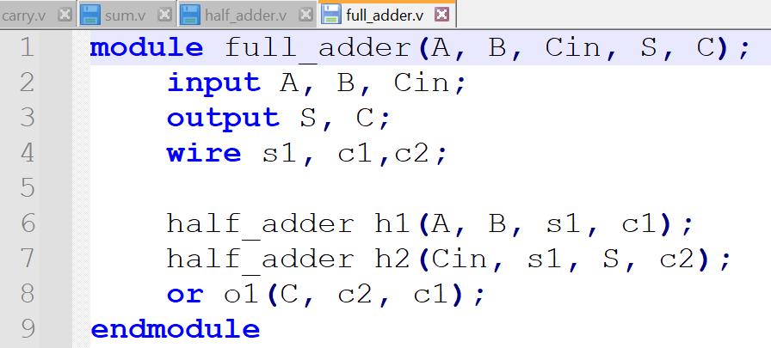
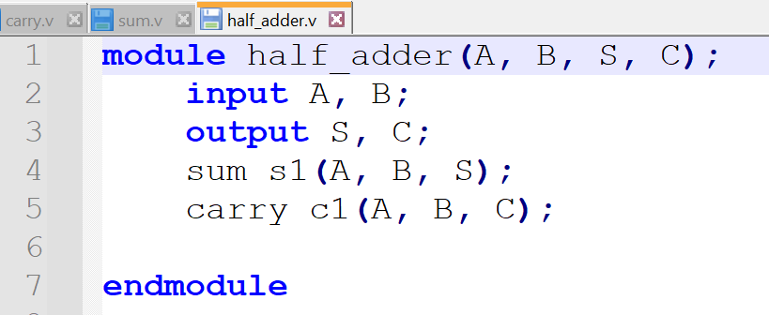
Figure 1.4: Full Adder Module
Figure 1.3: Half Adder Module
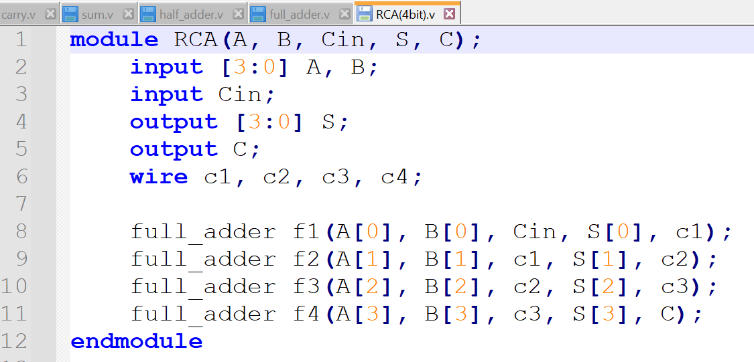

Figure 1.5: 4-bit Ripple Carry Adder
Test Bench:
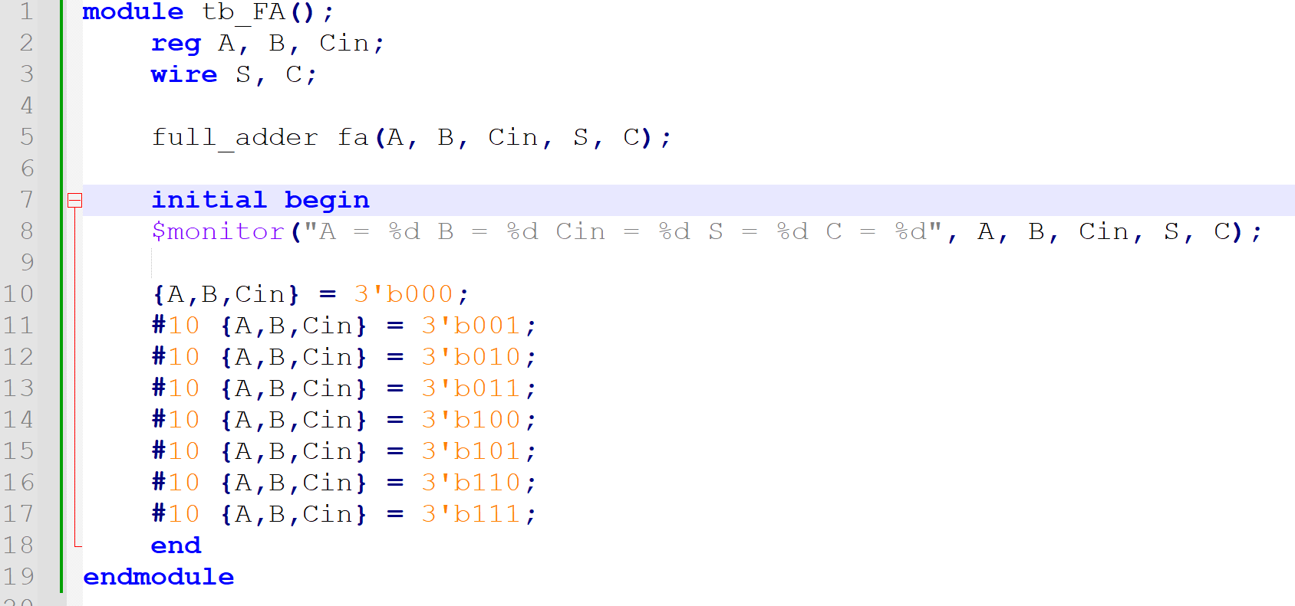
Figure 2.1: Test Bench for Full Adder
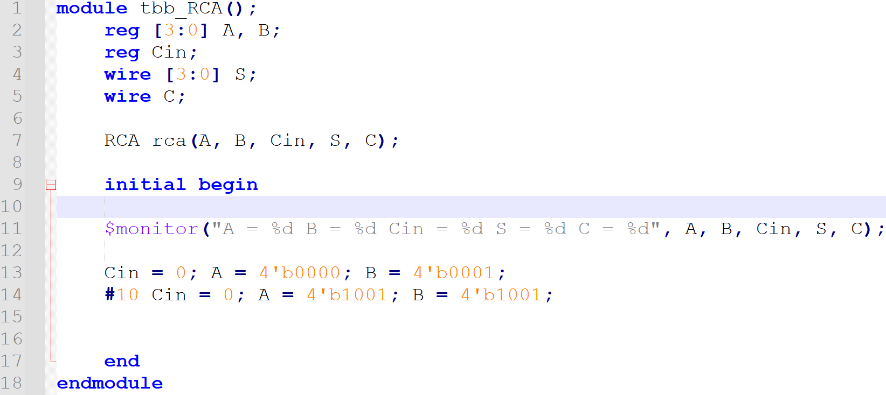
Figure 2.2: Test Bench for 4-bit Ripple Carry Adder

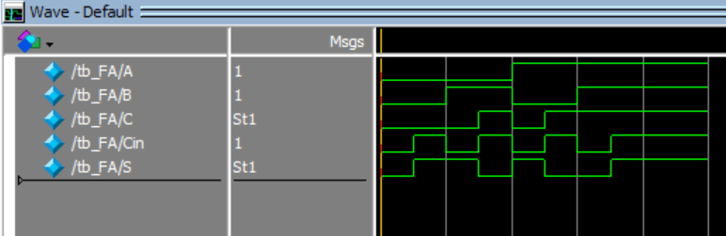
Output:
Figure 3.1: Output Waveform of Full Adder
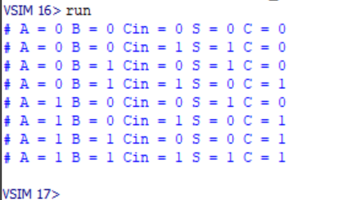

Figure 3.2: Truth Table of Full Adder
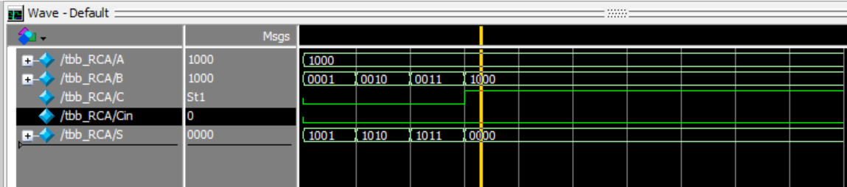
Figure 3.3: Output Waveform of 4-bit Ripple Carry Adder

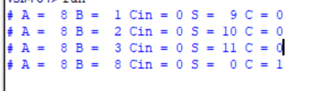

Figure 3.4: Output Table of 4-bit Ripple Carry Adder

Task 1b:
Design the 4 bit full adder using data flow level modeling.

Code:
DUT:
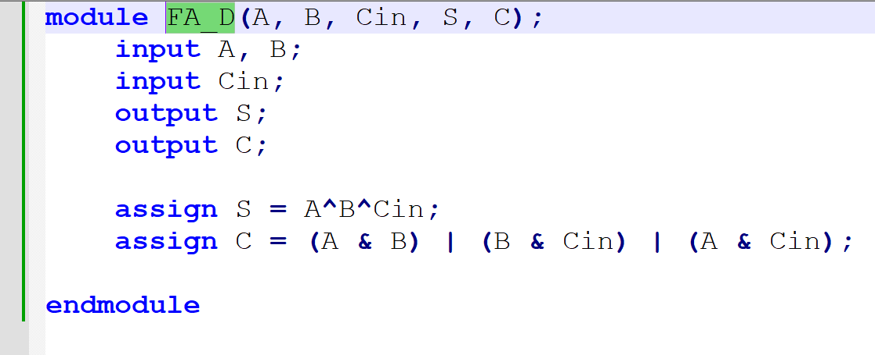
Figure 4.1: Full Adder Module Using Data Flow Modelling
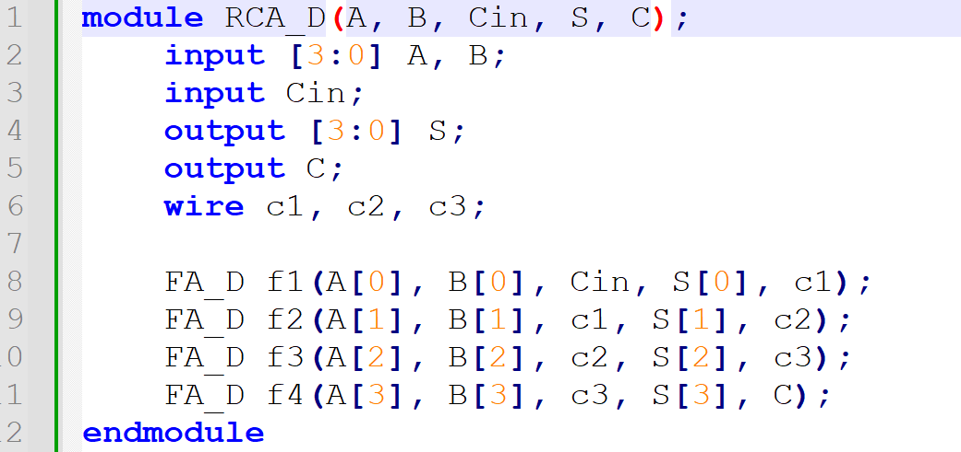
Figure 4.2: 4-bit Ripple Carry Adder Module Using Data Flow Modelling

Test Bench:
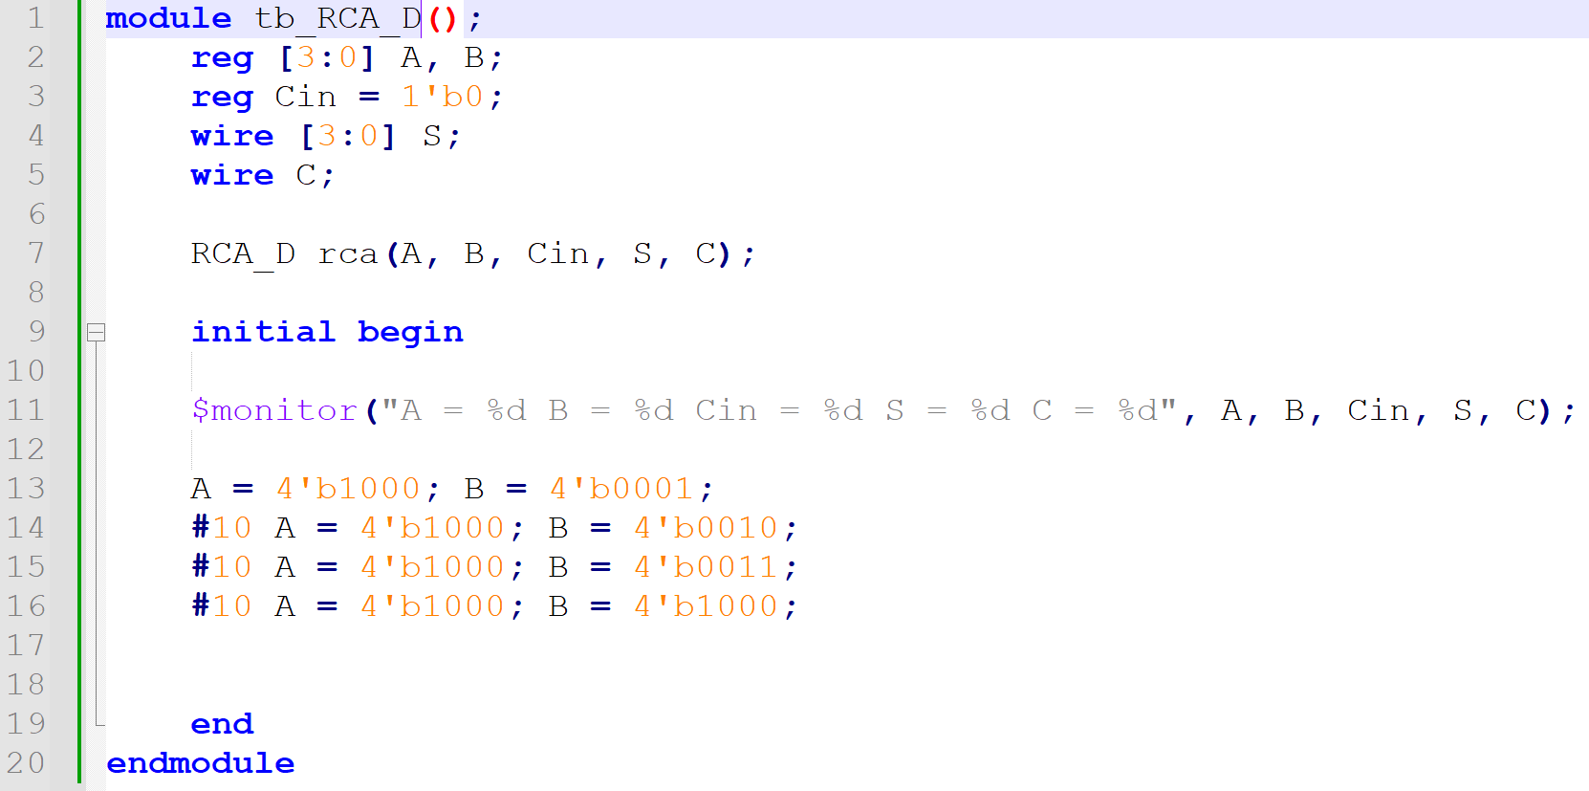
Figure 4.3: Test Bench for 4-bit Ripple Carry Adder Module Using Data Flow Modelling

Output:
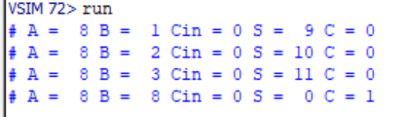
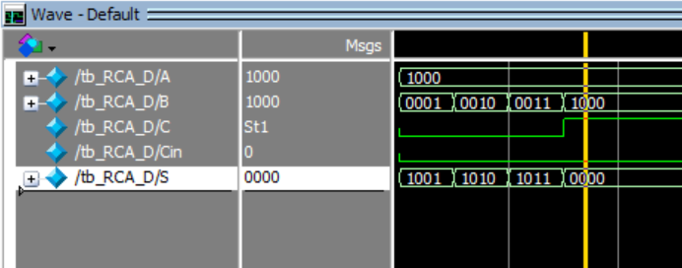
Figure 5.1: Output Waveform of 4-bit Ripple Carry Adder Module Using Data Flow Modelling

Figure 5.2: Output Table 4-bit Ripple Carry Adder Module Using Data Flow Modelling

